Lepa Angelkoska

Software Engineer

SUMMARY

.NET developer with demonstrated success in designing, developing and deployment of large scale web systems such as e-testing, banking, and elections. More than 6 years of experience as a developer.

COMPUTER LANGUAGES
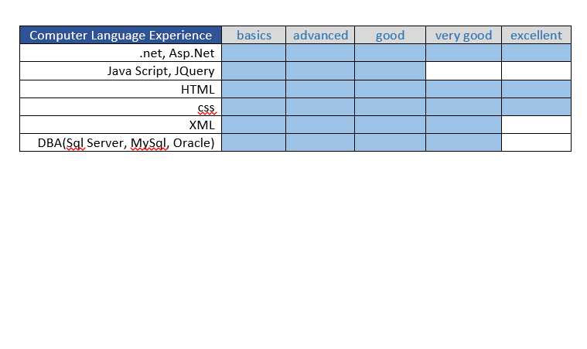

OTHER SKILL HIGHLIGHTS
- Agile / Scrum methodology
- Performance & Scalability Optimization
- Problem solving
- Detail Oriented
- Work Well Independently and Within a Team Setting

GET TO KNOW LEPA
More than 6 years of strong background working as a full stack developer in asp.NET. Great analytical and communication skills as well as very good team player.

EDUCATION

- B.S. in Computer Science at the University Ss. Cyril and Methodius, Faculty of Electrical Engineering and Information Technologies, Skopje Macedonia Sept 2006 – Sep 2011
- Courses:
- Developing ASP.NET MVC 4 Web Applications (2017).
- Business Analysis (2016)

LANGUAGES
Macedonian
Serbian

English ○

RECENT PROJECT EXPERIENCE
- 2017 – Agency for supervision of fully funded pension insurance - MAPAS
- 2016 - Universal testing solution
- 2015 - Smart home and Business Security solutions
- 2014 - Development of integrated election management platform
- 2013 – Banking software

